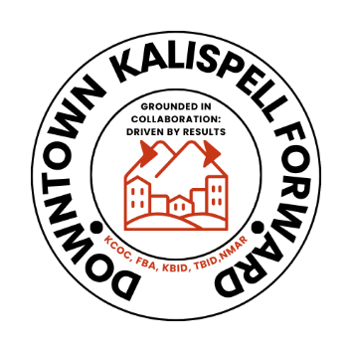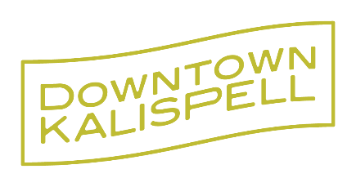

FOR IMMEDIATE RELEASE
February 24, 2026
Kalispell Chamber of Commerce and Downtown Association Announce Unified Path Forward for Downtown Kalispell
Kalispell, MT — The Kalispell Chamber of Commerce (KCOC) and the Kalispell Downtown Association (KDA) today announced a unified path forward that brings the Downtown Kalispell Association’s work into alignment with Downtown Kalispell Forward, strengthening coordination, expanding capacity, and positioning downtown for its next era of vitality and growth.
Following a unanimous vote of the Kalispell Downtown Association and the Kalispell Chamber of Commerce respective board of directors, this alignment reflects a shared commitment and value to building on the progress already underway through Downtown Kalispell Forward and ensuring downtown businesses and initiatives benefit from deeper organizational support, broader partnerships, and long-term sustainability.
“Downtown Kalispell plays a critical role in our community’s identity and economic future,” said Lorraine Clarno, CEO, KCOC. “This step connects the Kalispell Downtown Association directly to the Chamber’s economic development, workforce, advocacy, and business engagement efforts, creating a stronger and more coordinated platform to serve downtown businesses and the community as a whole.”
The board’s decision reflects confidence that aligning efforts will enhance momentum, provide additional infrastructure, and allow downtown initiatives to grow with greater impact.
“This decision represents thoughtful leadership and a focus on the future,” said Elma Giavasis, President, KDA. “The Downtown Association has been shaped by dedicated volunteers and supporters whose contributions helped create the vibrant downtown we see today. Aligning with Downtown Kalispell Forward ensures that work continues with expanded capacity, stronger partnerships, and lasting sustainability.”
Through this unified approach:
- Downtown Kalispell Forward will remain the community’s platform for downtown placemaking, business engagement, events, and revitalization initiatives.
- Downtown priorities will continue to be guided by dedicated leadership and active stakeholder involvement.
- KDA will dissolve as an entity, and assets will be transferred to the Kalispell Chamber Foundation to continue and grow the Kalispell Downtown Forward initiative.
- Downtown businesses will gain access to expanded marketing reach, streamlined communication, and stronger connections to economic development and advocacy resources.
- Community partners will benefit from a more coordinated and efficient structure for advancing downtown projects and opportunities.
City leaders, business owners, and community partners have increasingly collaborated through Downtown Kalispell Forward, making this alignment a logical next step in strengthening downtown’s role as a hub for commerce, culture, and community life.
“This is about building on momentum and creating the capacity needed for downtown’s continued success,” said Lorraine Clarno, KCOC. “By working together in a more integrated and cost effective way, we can better support our treasured downtown businesses, activate public spaces, and advance a shared vision for downtown Kalispell.”
The transition will occur over the coming months, with a focus on continuity for downtown businesses, sponsors, volunteers, and community partners.
For more information about Downtown Kalispell Forward and upcoming initiatives, visit https://kalispellchamber.com/programs/downtown-forward/, email: dkf@kalispellchamber.com or call 406-407-4144.

